
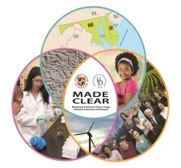
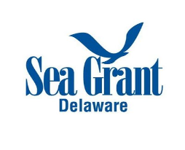

2018 Climate Academy Agenda
A NOAA and MADE CLEAR Earth Science Professional Learning Opportunity

Academy Themes
- Climate, Environmental Change, and Meaningful Watershed Education Experiences

Academy Goals
- Participants will know major climate change content, including the causes and mechanisms of climate change; evidence for the human role in climate change; regional and global impacts of climate change; and solutions to address and mitigate climate change impacts
- Participants will be familiar with Next Generation Science Standards (NGSS) connections and teaching ideas for each of the four main climate topics covered in the Academy
- Participants will know where to find climate change science information and data, climate change education resources, and people to contact for guidance
- Participants will develop a plan for teaching about climate change and framing it in the context of a Meaningful Watershed Educational Experience (MWEE)
- Participants will develop a plan for their own continuing professional learning in climate change education

Academy Components
- Online - Content Phase
- In-Person - Experiential Phase
- In Your Class or Program - Implementation Phase

Course Orientation Webinar: May 21, 7:00-8:00pm
Overview of the course and introduction to the Chesapeake Exploration Moodle online learning management system

Online Component - May 21 - June 26
Self paced, with recommended timelines; on-line lessons and resources will remain posted during and after the in-person component of the course

- Introduction and Background
- Session 1: Earth Systems, Weather, Climate and Evidence of a Changing Climate
- Session 2: Earth's Carbon Cycle, Heat Trapping Gases, and the Human Factor
- Session 3: Climate Change Impacts and Responses

In-Person Component - June 26-28
Location: University of Delaware Hugh R. Sharp Marine Studies Campus, Lewes, DE
Housing and meals will be provided from Monday evening June 25 through Thursday June 28

- Day 1: Issue Definition
  - What evidence is there that our planet is warming?
  - What is the role of the carbon cycle in the climate system?
  - What is the evidence for a human role in climate change?

- Day 2: Outdoor Field Experience(s)
  - How can we structure climate-relevant field-based investigations?
    - Engage in model opportunities for experiences, explorations and investigations of climate topics in a field-based context
    - Explore Citizen Science opportunities for students

- Day 3: Synthesis and Conclusions and Action Projects
  - How can we use science and engineering practices to understand and address the causes and impacts of a changing climate ?
  - Exploring solutions to climate change

Academy Requirements:
- Participate in all Academy Components (Online, In-person, Implementation)
- At the end of the Academy submit an implementation plan
- At the end of the Academy submit a professional learning plan
- 3 CPD (continuing professional development) credits are available through MSDE
- DE professional development clock hours are available

A $300 stipend is available upon completion of requirements.

This Academy is funded in part by a grant from National Science Foundation DUE-1239758


